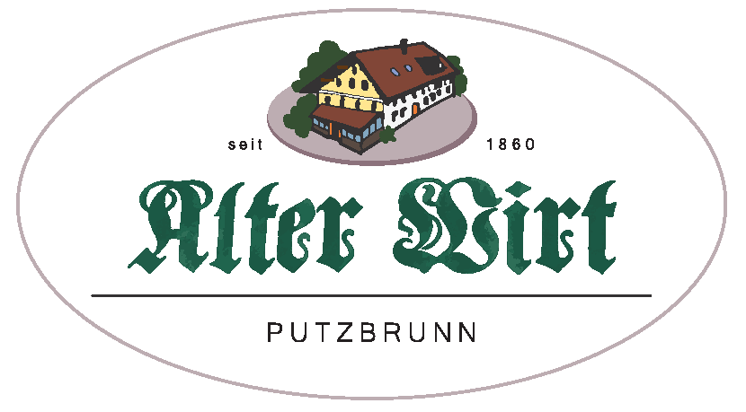
🥣 Soups
Beef Consommé
with pancake strips and vegetables – €6.90
Beef Consommé
with liver dumplings and vegetables – €6.90

🥗 Salads
Small Mixed Side Salad
with house dressing – €4.90
Large Mixed Leaf Salad
with cucumber, sun-dried tomatoes, olives, and radishes – €11.90
Optional add-on:
– Gratinated goat cheese +€5.00
Caesar Salad – €17.90
with breaded chicken breast and croutons

🧀 Bavarian Specialties
Bavarian Sausage Salad – €10.80
with pickles, radishes, red onions, and baguette
Swiss Sausage Salad – €11.80
with Emmental cheese, pickles, radishes, red onions, and baguette
Obazda (Bavarian cheese spread) with a pretzel – €11.90
Large “Putzbrunn” Snack Platter – €17.90
with assorted sausages and cheeses, fresh horseradish, pickles, and baguette
Large Vegetarian Snack Platter – €16.90
with cheese, Obazda, spreads, olives, fig mustard,
red onions, chives, pickles, and baguette

🍖 Main Courses
Veal Wiener Schnitzel – €26.90
fried in clarified butter, with roasted potatoes, cranberries, and mixed salad
Corn-Fed Chicken Breast – €21.90
fried in herb butter, served with sweet potato purée and green asparagus
Roast Beef with Onions (Zwiebelrostbraten) – €27.90
with roasted potatoes and seasonal vegetables
Swabian Grill Plate – €21.90
pork fillet with cheese spätzle, creamy mushrooms, and crispy onions
Sliced Beef Tenderloin – €22.90
in pepper cream sauce with roasted potatoes
Cordon Bleu – €19.90
ham and cheese filling, fried in clarified butter, served with fries
Munich Schnitzel – €18.90
with homemade potato salad
Beef Burger (200g) with Cheddar – €18.90
with lettuce, tomato, pickles, red onion, homemade sauce, and fries
Breaded Turkey Schnitzel – €19.90
fried in clarified butter, served with fries
Pretzel-Crusted Pork Schnitzel – €17.20
with roasted potatoes
Roast Pork – €15.90
with two types of dumplings and bacon cabbage salad
Homemade Meat Patties – €14.90
with potato salad and gravy

🐟 From the Water
Rainbow Trout “Müllerin Style” – €22.90
with boiled potatoes and seasonal vegetables

🌱 Vegetarian Dishes
Homemade Cheese Spätzle – €15.90
with melted onions, crispy onions, and mixed salad
Creamy Mushrooms – €13.90
with bread dumplings and fresh herbs
Arancini (fried risotto balls) – €17.90
with cherry tomato sauce and green asparagus
Spinach Risotto – €17.90
with fresh asparagus

🍰 Desserts
Caramelized Kaiserschmarrn – €14.90
with almonds, raisins, and apple sauce
(freshly made, approx. 20 minutes)
Apple Strudel with Vanilla Sauce – €7.90
- scoop of vanilla ice cream +€2.10
Mixed Ice Cream with Hot Raspberries – €7.90
2 Scoops of Ice Cream – €4.20
(vanilla and chocolate)

👧 For Our Little Guests
Spätzle or Dumplings with Sauce – €4.90
Small Wiener Schnitzel with Fries – €7.90

🥨 Morning Special (until 2:30 PM)
2 Munich White Sausages
with pretzel and sweet mustard – €7.80
Each additional sausage – €2.80

🍟 Side Dishes
Fries – €4.60
Roasted potatoes – €4.60
Seasonal vegetables – €4.90
Coleslaw – €3.90
Pretzel – €1.50
Baguette – €1.50
Butter – €1.30

All prices include VAT and are in Euros.

